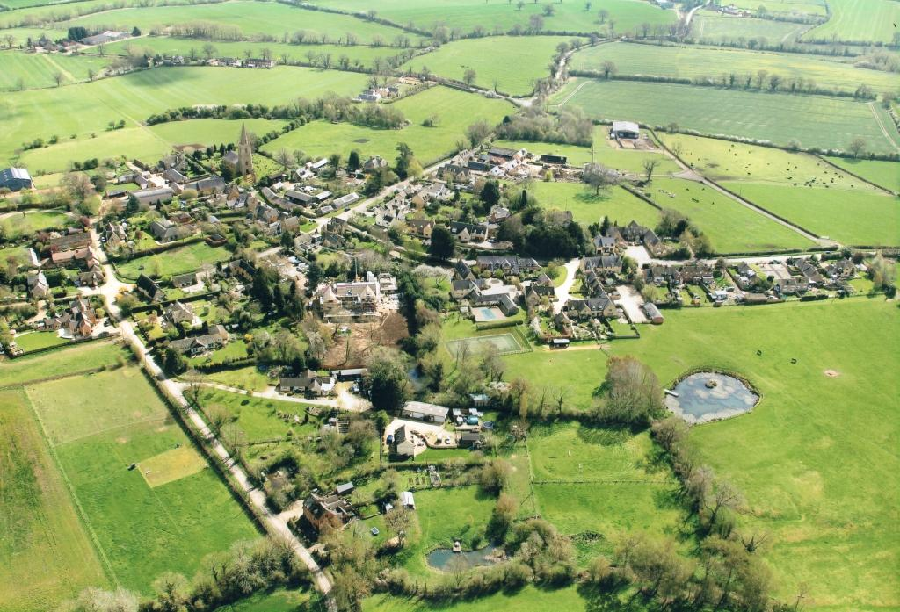

Printed by XYZ Company

**Great Wolford**

**Village Design Statement - 2019**

**Development Guidelines for the South Warwickshire Village of Great Wolford**

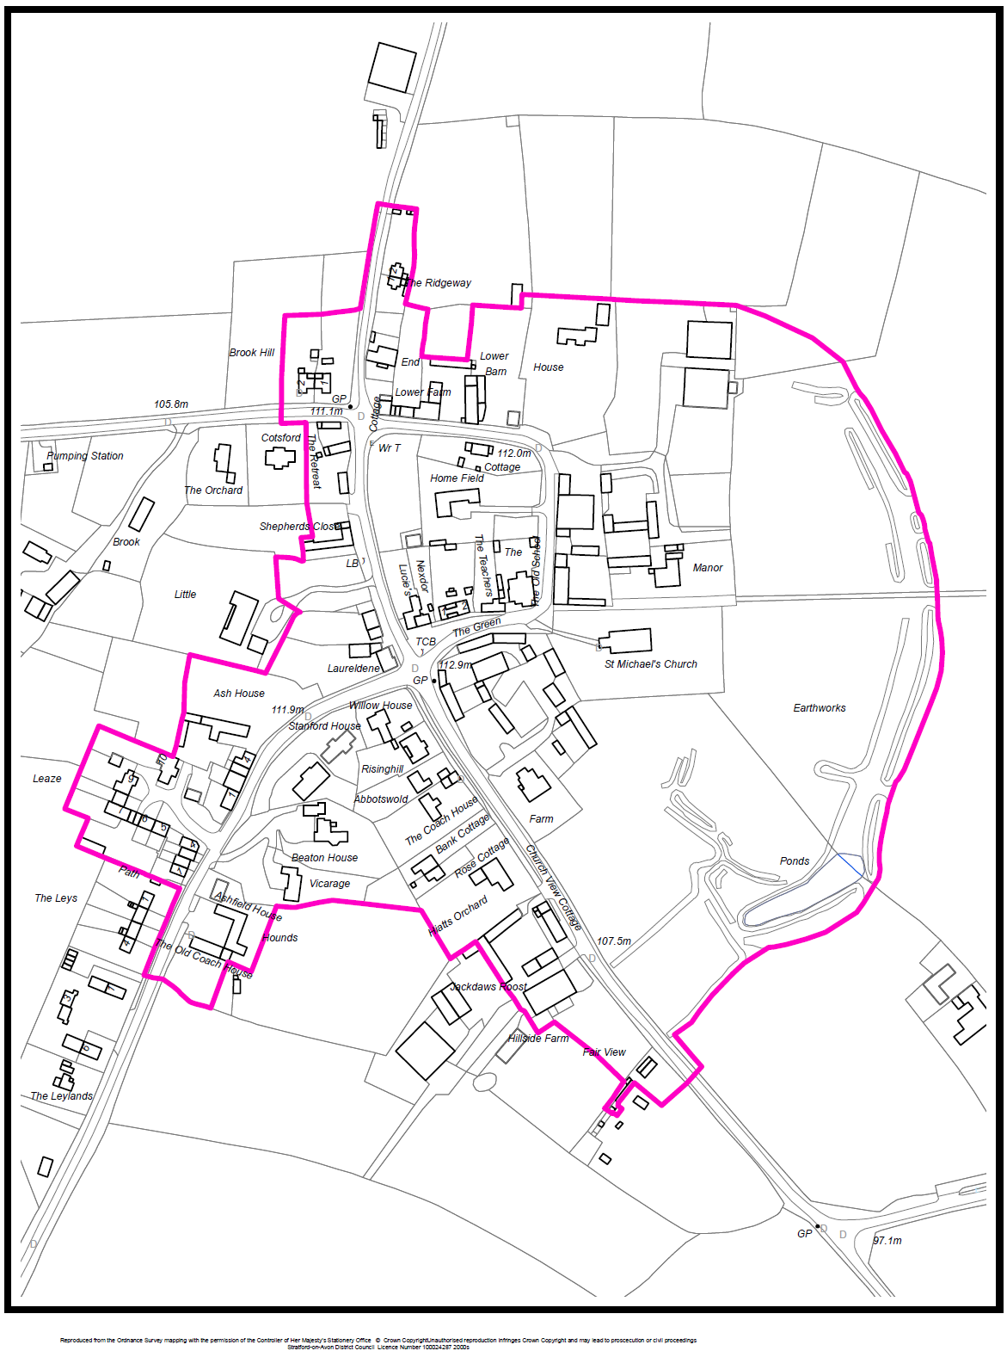

***Map 2 – The Great Wolford Conservation Area***

